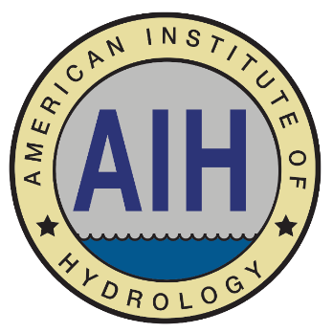
The American Institute of Hydrology (AIH) announces a Call for
Nominations for its Board of Directors.

The organization is requesting nominations for the position of Director of International Affairs.
Nominations are due March 1, 2024, and elections will be held thereafter.

Candidate Eligibility:
In order to be eligible for the Director of International Affairs position, the candidate must be an AIH member in good standing, and must be either a P.H. or a Hydrologic Technician Level III.

Director of International Affairs Responsibilities:
The Director of International Affairs shall promote the Institute internationally through collaboration with organizations supporting the mission of the Institute, represent international members of the Institute, and assist in the planning for international activities.

Position Terms:
The terms for the position will begin as soon as elected. The term of the elected position is for four years.

Nomination Process
AIH invites and encourages its members to consider applying for this position. You may nominate yourself or another eligible member. To be considered, please submit your nomination to admin@aihydrology.org by March 1. 2024.

A complete submission must include:
- Your name, professional title, email address, and preferred phone number.
- A statement that you are nominating yourself or another member. If nominating another member, please also provide their name, professional title, email address, and preferred phone number.
- The nominee’s statement of interest (maximum 150 words)
- The nominee’s professional biography (maximum 150 words)

AIH appreciates your interest. If you have any questions, please contact the AIH Board Office at (540) 500-1933 or admin@aihydrology.org.

