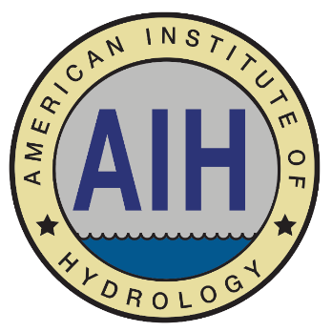
The American Institute of Hydrology (AIH) announces a Call for
Nominations for its Board of Directors.

The organization is requesting nominations for the position of Director of Communications.
Nominations are due March 1, 2024, and elections will be held thereafter.

Candidate Eligibility:
In order to be eligible for the Director of Communications position, the candidate must be an AIH member in good standing, and must be either a P.H. or a Hydrologic Technician Level III.

Director of Communications Responsibilities:
The Director of Communications shall have general responsibility for the certification program of the Institute; oversee student membership; and, in coordination with the Director of Institute Development, establish collaborative relationships with academic institutions to support the mission of the Institute.

Position Terms:
The terms for the position will begin as soon as elected. The term of the elected position is for four years.

Nomination Process
AIH invites and encourages its members to consider applying for this position. You may nominate yourself or another eligible member. To be considered, please submit your nomination to admin@aihydrology.org by March 1, 2024.

A complete submission must include:
- Your name, professional title, email address, and preferred phone number.
- A statement that you are nominating yourself or another member. If nominating another member, please also provide their name, professional title, email address, and preferred phone number.
- The nominee’s statement of interest (maximum 150 words)
- The nominee’s professional biography (maximum 150 words)

AIH appreciates your interest. If you have any questions, please contact the AIH Board Office at (540) 500-1933 or admin@aihydrology.org.

